Arduino Remote Using I2C

In the next demonstration we will hook a potentiometer to the master Arduino and an LED to the slave. We will use the potentiometer to control the blink rate of the LED.

This is another simple demonstration, you can build upon it to create something more practical.

Remote Demo Hookup

Here is how this experiment is put together.

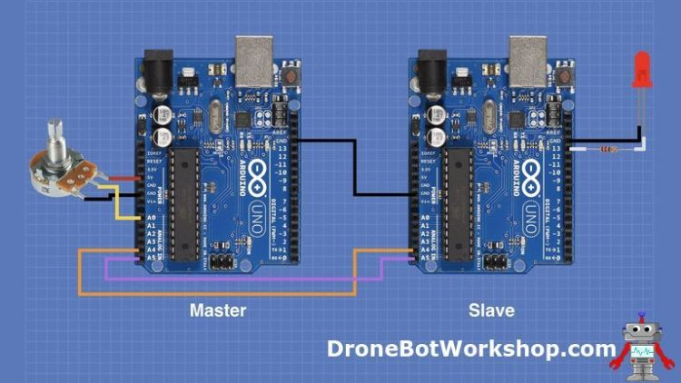

It is essentially the same hookup as the previous experiment, with the addition of the potentiometer on the master and the LED on the slave.

Note that the LED on the slave has been attached to pin 13. As the Arduino Uno has a built-in LED on pin 13 you may eliminate the LED and its dropping resistor if you wish.

The remarks about pull-up resistors also apply to this hookup.